**Computer Peripherals**

Lecture Notes – Week 8

*G.  MacKenzie, I. Bojanova, Z. Xu*

**Introduction**

This week we study several typical peripherals, including storage, display, and other input devices.

**Solid-State Memory**

Also known as flash memory, the solid-state memory has such advantages over the magnetic disks as light weight, fast access, less energy consumption (hence less heat), immune to physical shocks. As the prices of flash memory come down, they will replace the magnetic disk in the foreseeable future.

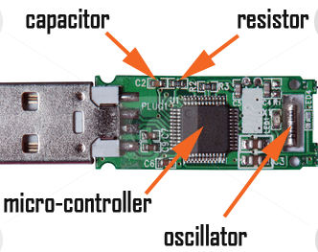

***Figure 8.1 – An Example of Flash Memory Circuit Board***

Here is a good reference for SSD technology: [http://searchstorage.techtarget.com/definition/solid-state-storage](https://www.dropbox.com/referrer_cleansing_redirect?hmac=XHTwOeCgw93gqyPQzqf%2F%2BZ2%2FefVhAOPIl5pe91jjSnU%3D&url=http%3A%2F%2Fsearchstorage.techtarget.com%2Fdefinition%2Fsolid-state-storage)  
[http://whatis.techtarget.com/definition/solid-state-storage-technologies-comparison](https://www.dropbox.com/referrer_cleansing_redirect?hmac=WJYgLpr6DSw6fellC81jjZRYyOXYSwPRdGsnDFhgV2A%3D&url=http%3A%2F%2Fwhatis.techtarget.com%2Fdefinition%2Fsolid-state-storage-technologies-comparison)

**Magnetic Disk Technology**

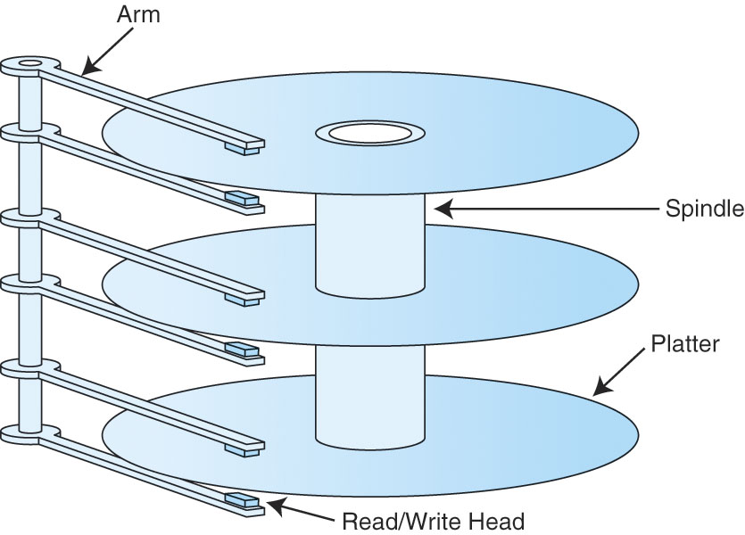

***Figure 8.2 - Rigid disk actuator (with read/write heads) and disk platters***

**Optical Disks**

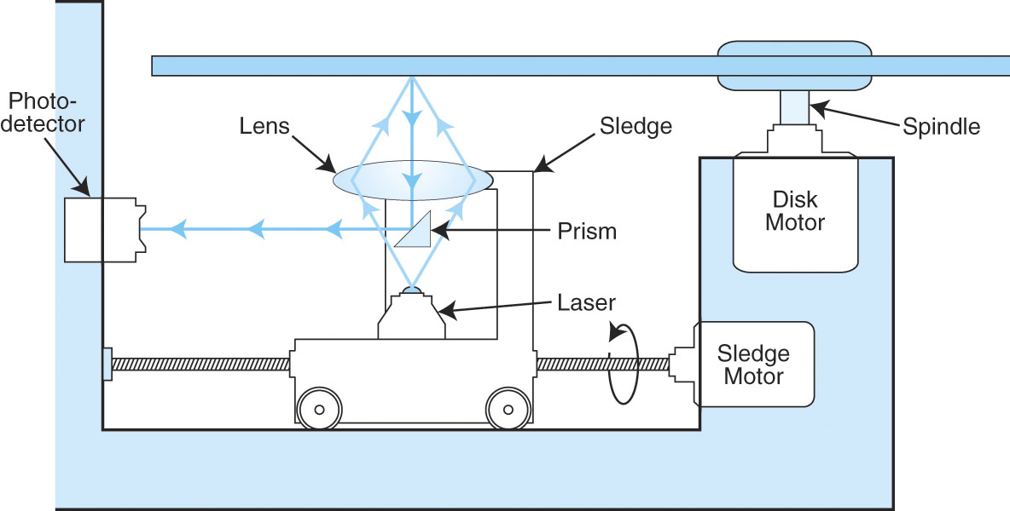

***Figure 8.3 - The internal of a CD-ROM drive***

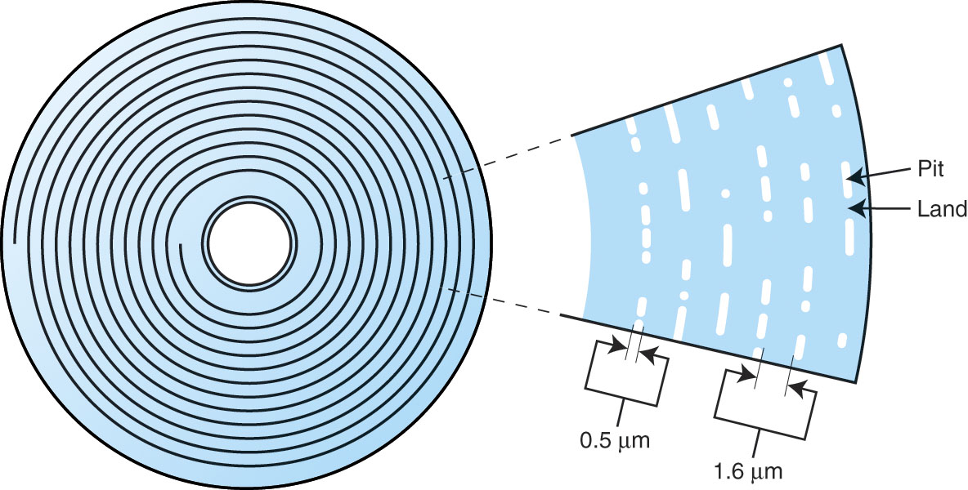

***Figure 8.4 - CD track spiral and track enlargement***

**RAID**

RAID devices provide redundancy (in different ways) in storing data, thus offering improved performance and increased availability for systems employing these devices. Levels 0 through 6, as well as some hybrid systems, are introduced.

***http://polaris.umuc.edu/~ibojanov/CSMN%20611/Session8_files/Fig.07.20.jpg***

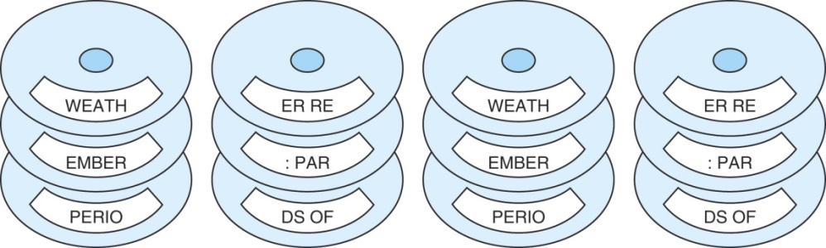

***Figure 8.5 - RAID-1, disk mirroring***

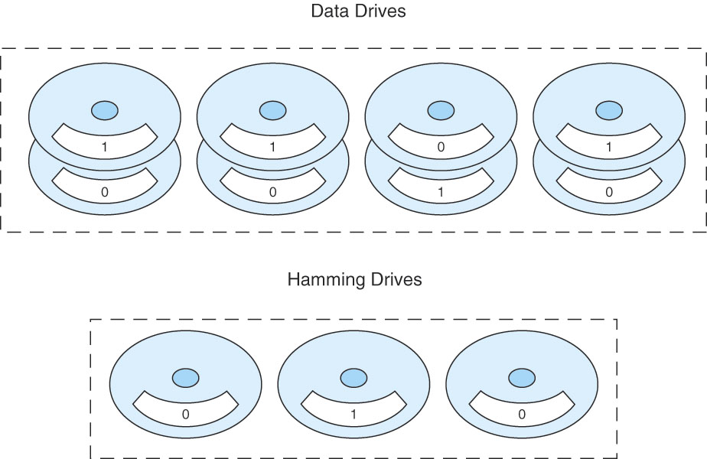

***Figure 8.6 - RAID-2, bit interleave data striping with a hamming code***

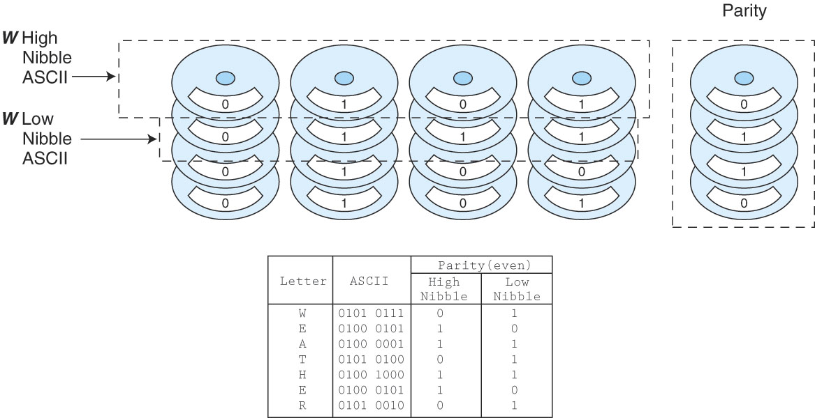

***Figure 8.7 - RAID-3, bit interleave data striping with parity disk***

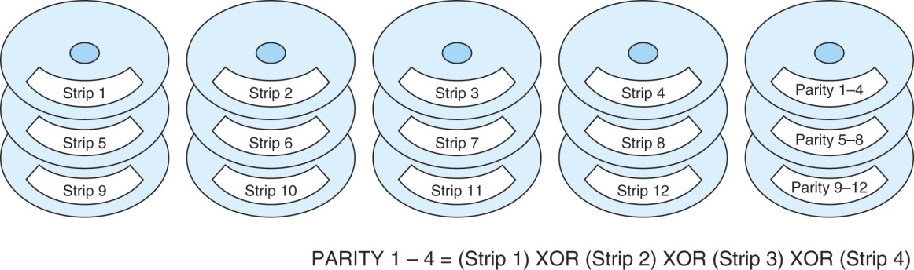

***Figure 8.8 - RAID-4, block interleave data striping with one parity disk***

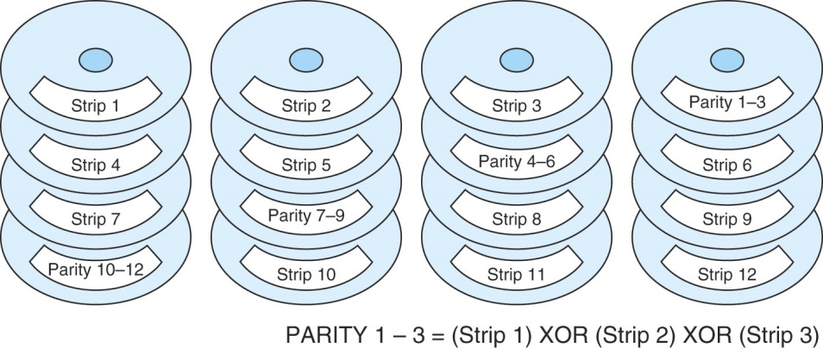

***Figure 8.9 - RAID-5, block interleave data striping with distributed parity***

|  |
| --- |
| ***http://polaris.umuc.edu/~ibojanov/CSMN%20611/Session8_files/Fig.07.26.jpg*** |

***Figure 8.10 - RAID-6, block interleave data striping with dual error protection***

**Optical Disk Storage**

Similar to magnetic disks, but they have only one spiral track. Also, different technologies lead to different formats with different capacities.

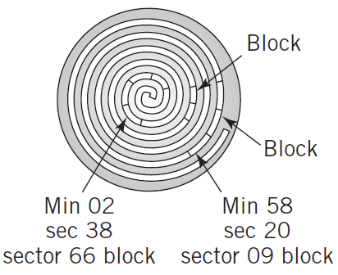

***Figure 8.11 – Example of an Optical Disk Storage***

**Magnetic Tape**

They are still in use due to financial and security reasons. Here is a good reference for magnetic tape:

<https://phys.org/news/2017-08-team-magnetic-tape-storagemakes-competitive.html>

**Display**

LCD and LED displays dominate the market now. They come in different sizes, resolutions, pixel densities, requiring different memory spaces. With Graphical Processing Units, they free up CPU and perform well.

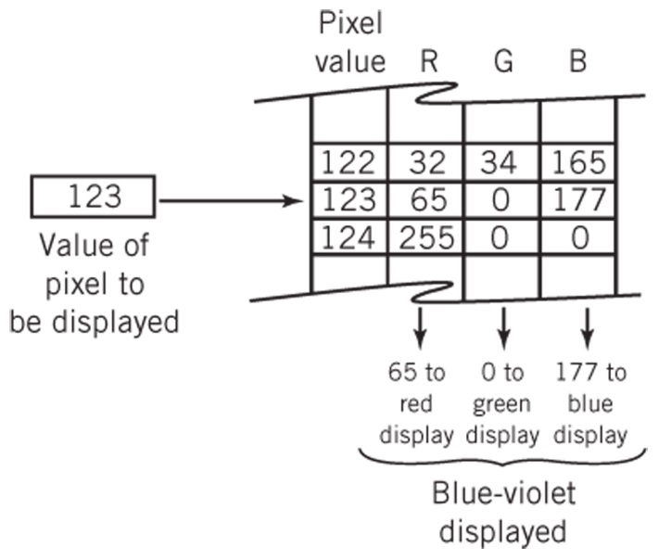

***Figure 8.12 – Color Transformation Table***

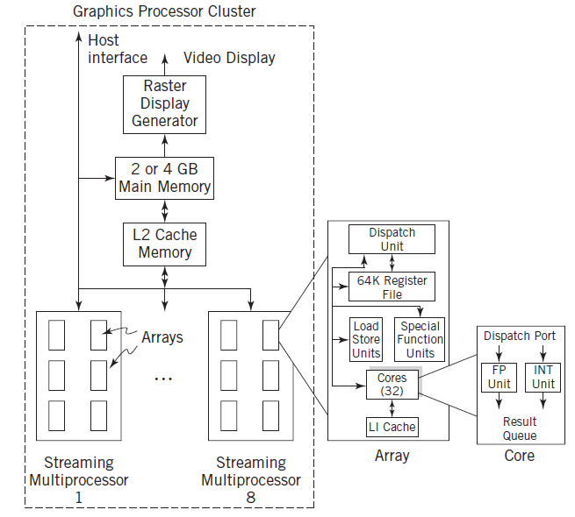

***Figure 8.13 – Typical GPU Block Diagram***

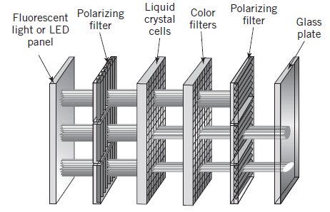

***Figure 8.14 – Liquid Crystal Display***

**Printer**

This week we also covered different types of printers, introducing dots vs. pixels.

**User Input Devices**

Creative methods of input provide convenient access, hence enable new applications on computers and mobile devices. On the other hand, new applications drive the usage of new input technologies.

* Keyboards
* Pointing Devices
* Alternative Sources of Alphanumeric Input
* Scanners
* Multimedia Input
* Mobile Devices

References

Doyle, Leo F. (1999). *Computer Peripherals*. Prentice Hall, 2nd edition.